Project C: Shading & Lighting Control 3D Scene

Yiming Dai YDF9097

* **Goal**

The goal of this project was to create realistic interactive lighting and materials in WebGL in a ‘virtual world.’ It is a world where the user can explore with different lighting/shading methods illuminating the shapes. The ‘virtual world’ are made from different materials, each with individually-specified emissive, ambient, diffuse, specular parameters.

The objects of the world are on a ground plane surface. Each of the object has its individual normal that reflected the light from both a user-adjustable light source and a headlight attached to the camera.

* **User’s instructions**

Upon opening the html file in the browser, there is a Shading & Lighting Control 3D ‘virtual world’, an instruction part and a control panel.

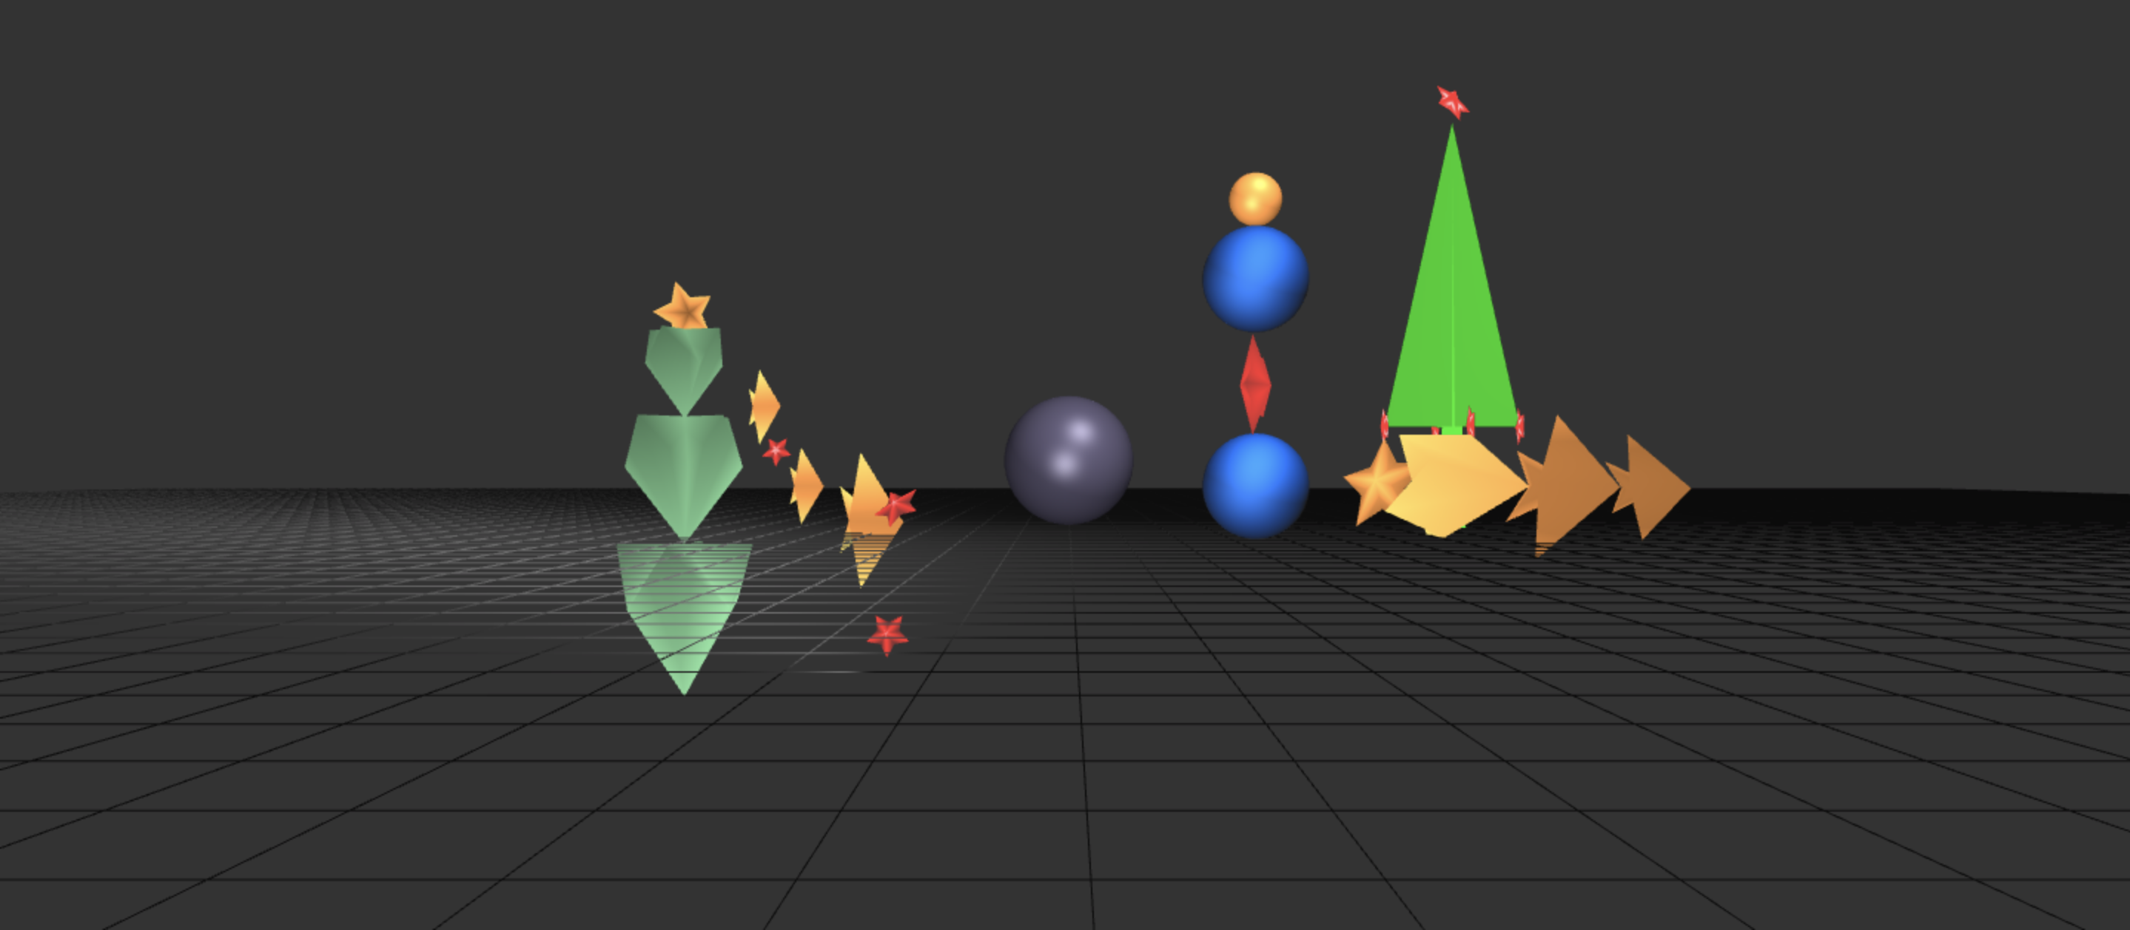

Figure 1 original world

Figure 1 above shows the 3D world. There are several jointed objects moving on the screen. And there is a sphere on the ground plane.

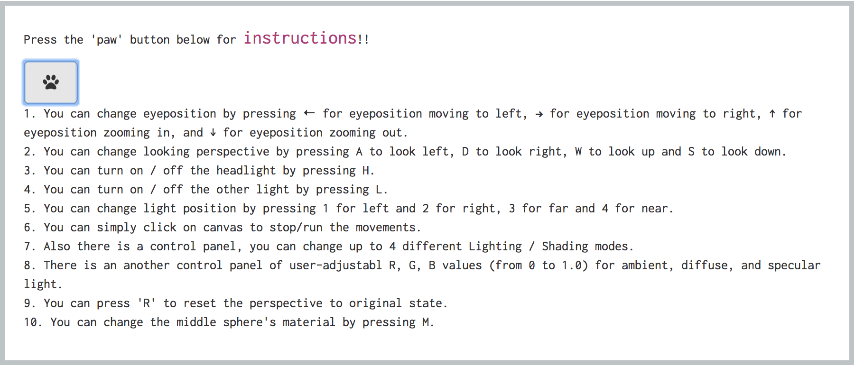

Figure 2 user instructions

Figure 2 above shows user instructions. By pressing the ‘paw’ button, instructions will show up. And user can follow instructions to know how to alter objects on the screen and move the camera around the world space.

Figure 3 control panel

Figure 3 above shows two control panels. User can control lighting & shading modes.

* **Results**

Below are some pictures showing the program results. The original world is shown in Figure 1. There is a tree with stars on it on the right side of the scene, and there is a spinning pillar on the left side of the scene. Also, there is a sphere in the middle of the scene.

By following instructions, user can alter lighting & shading modes and move the camera around the world space.

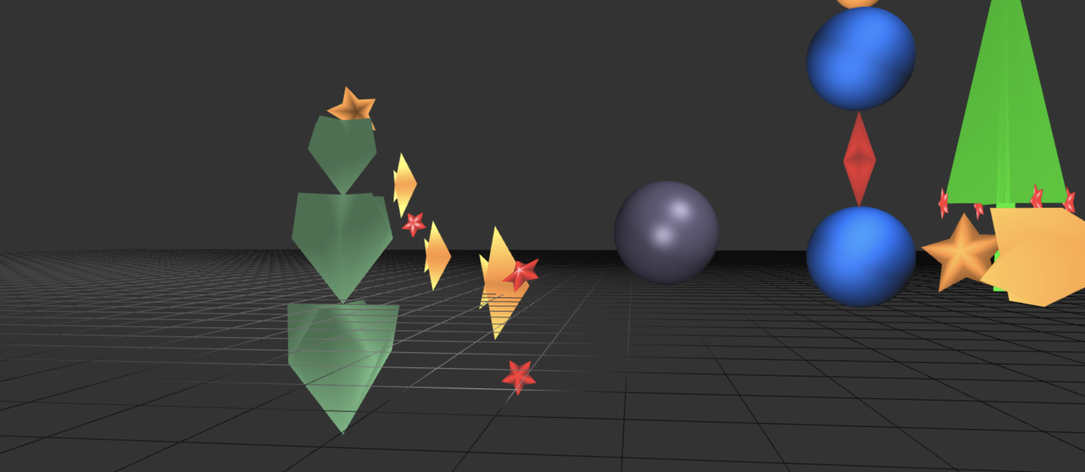

Figure 4 change looking perspective & eye position

Figure 4 shows a result of changing looking perspective and eye position.

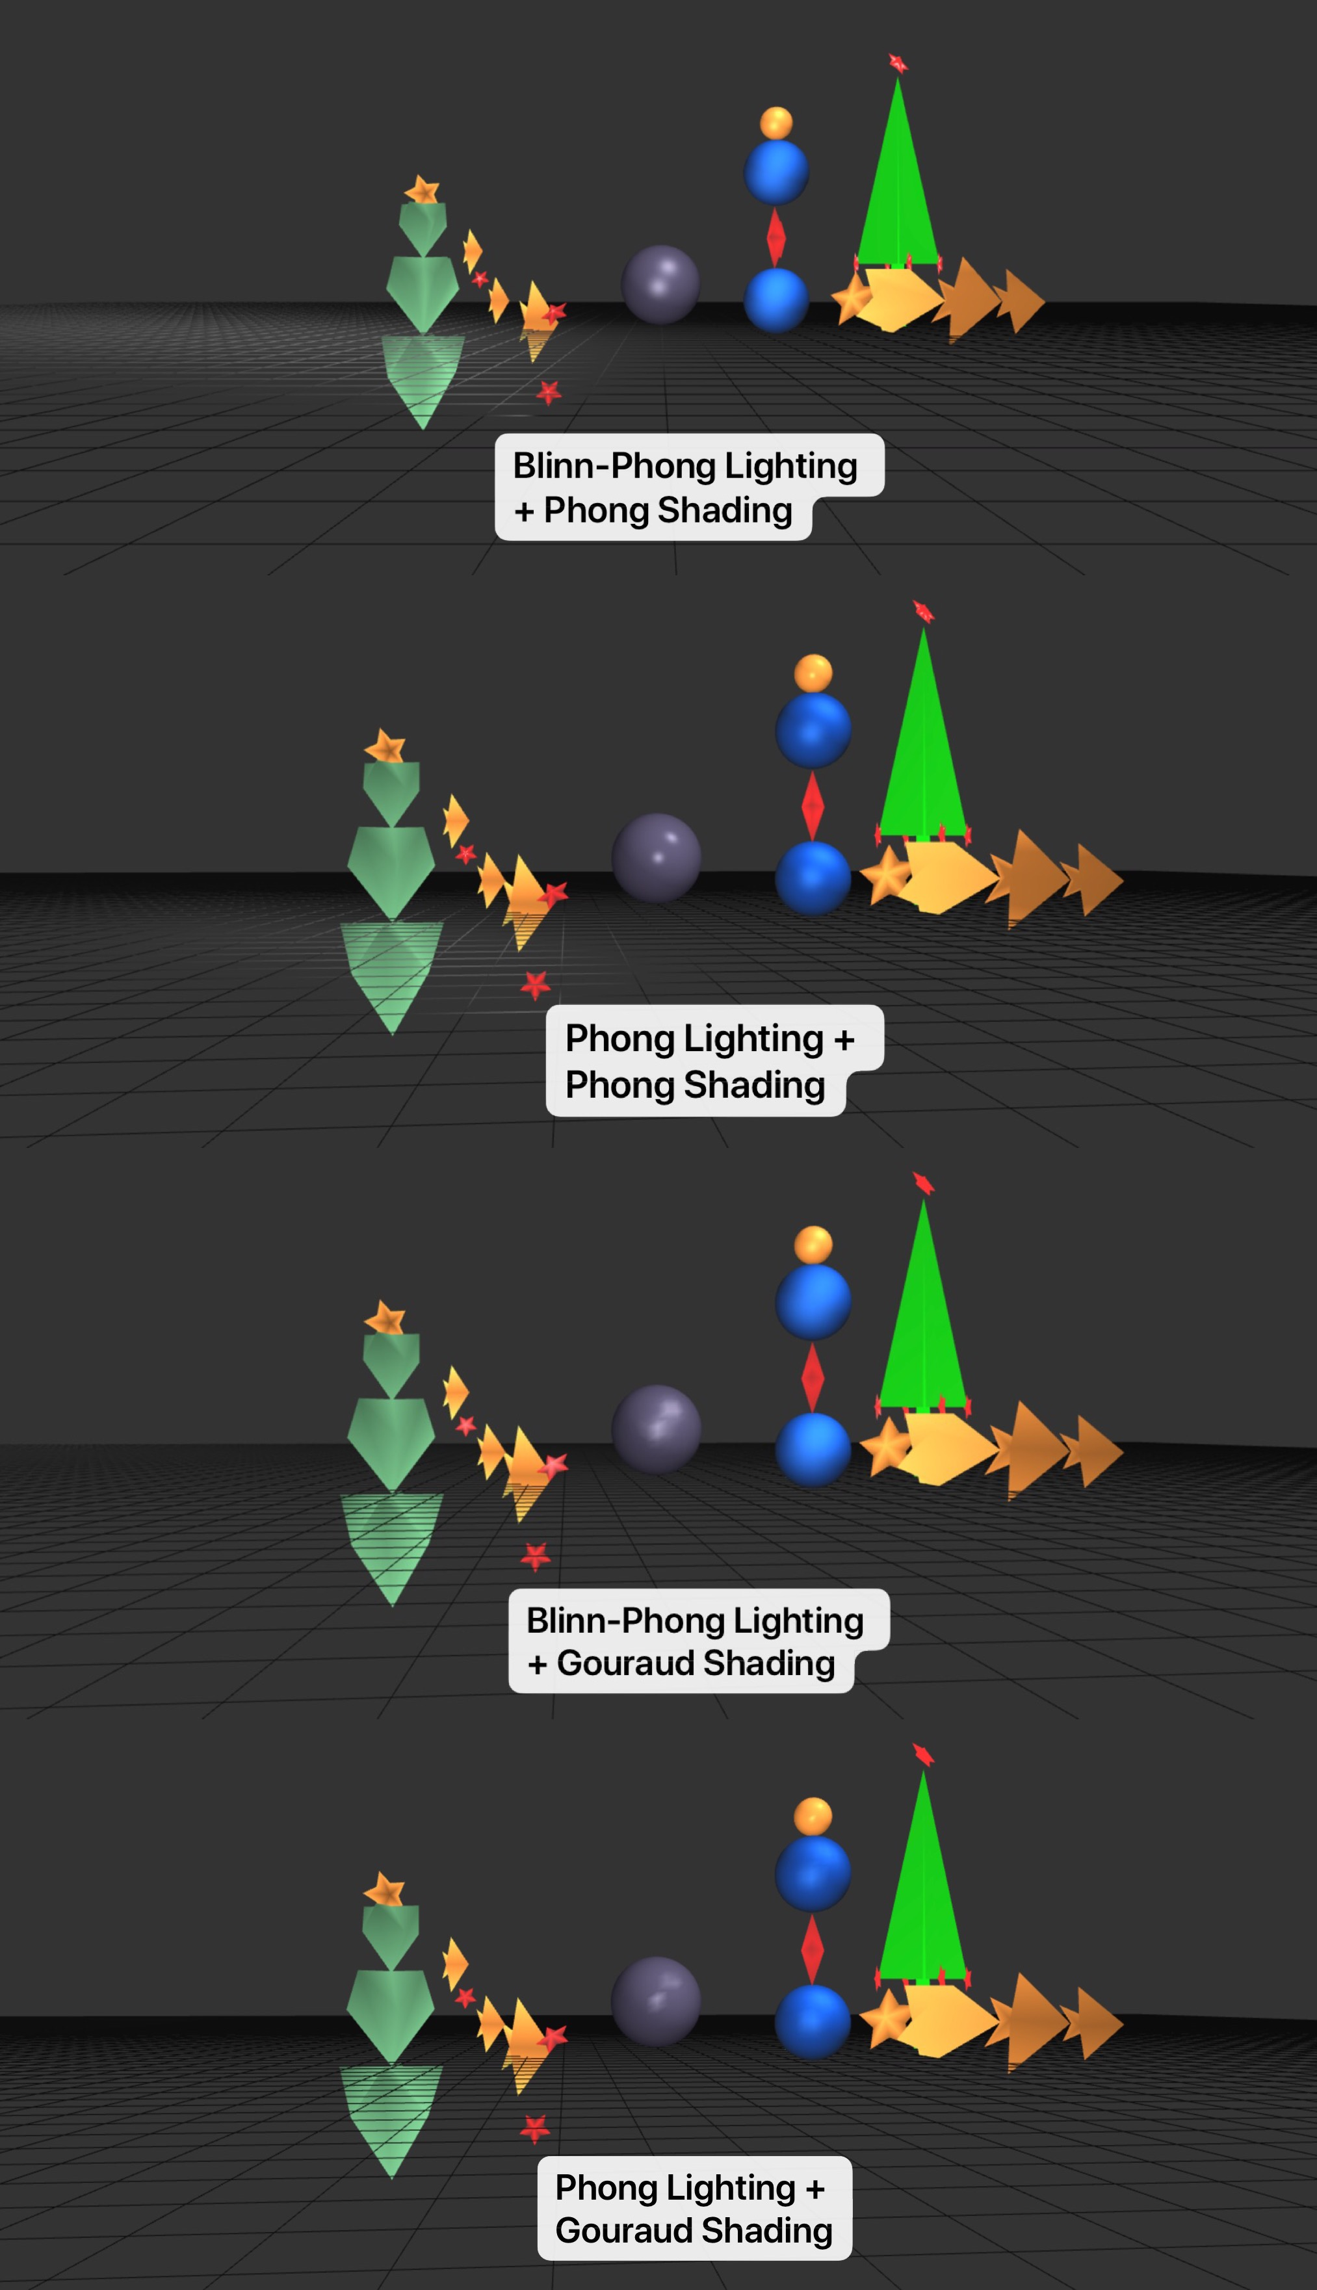

Figure 5 Four Mods of Lighting & Shading

Figure 5 shows results of changing different lighting & shading modes of Phong Lighting, Blinn-Phong Lighting, Phong Shading and Gouraud Shading.

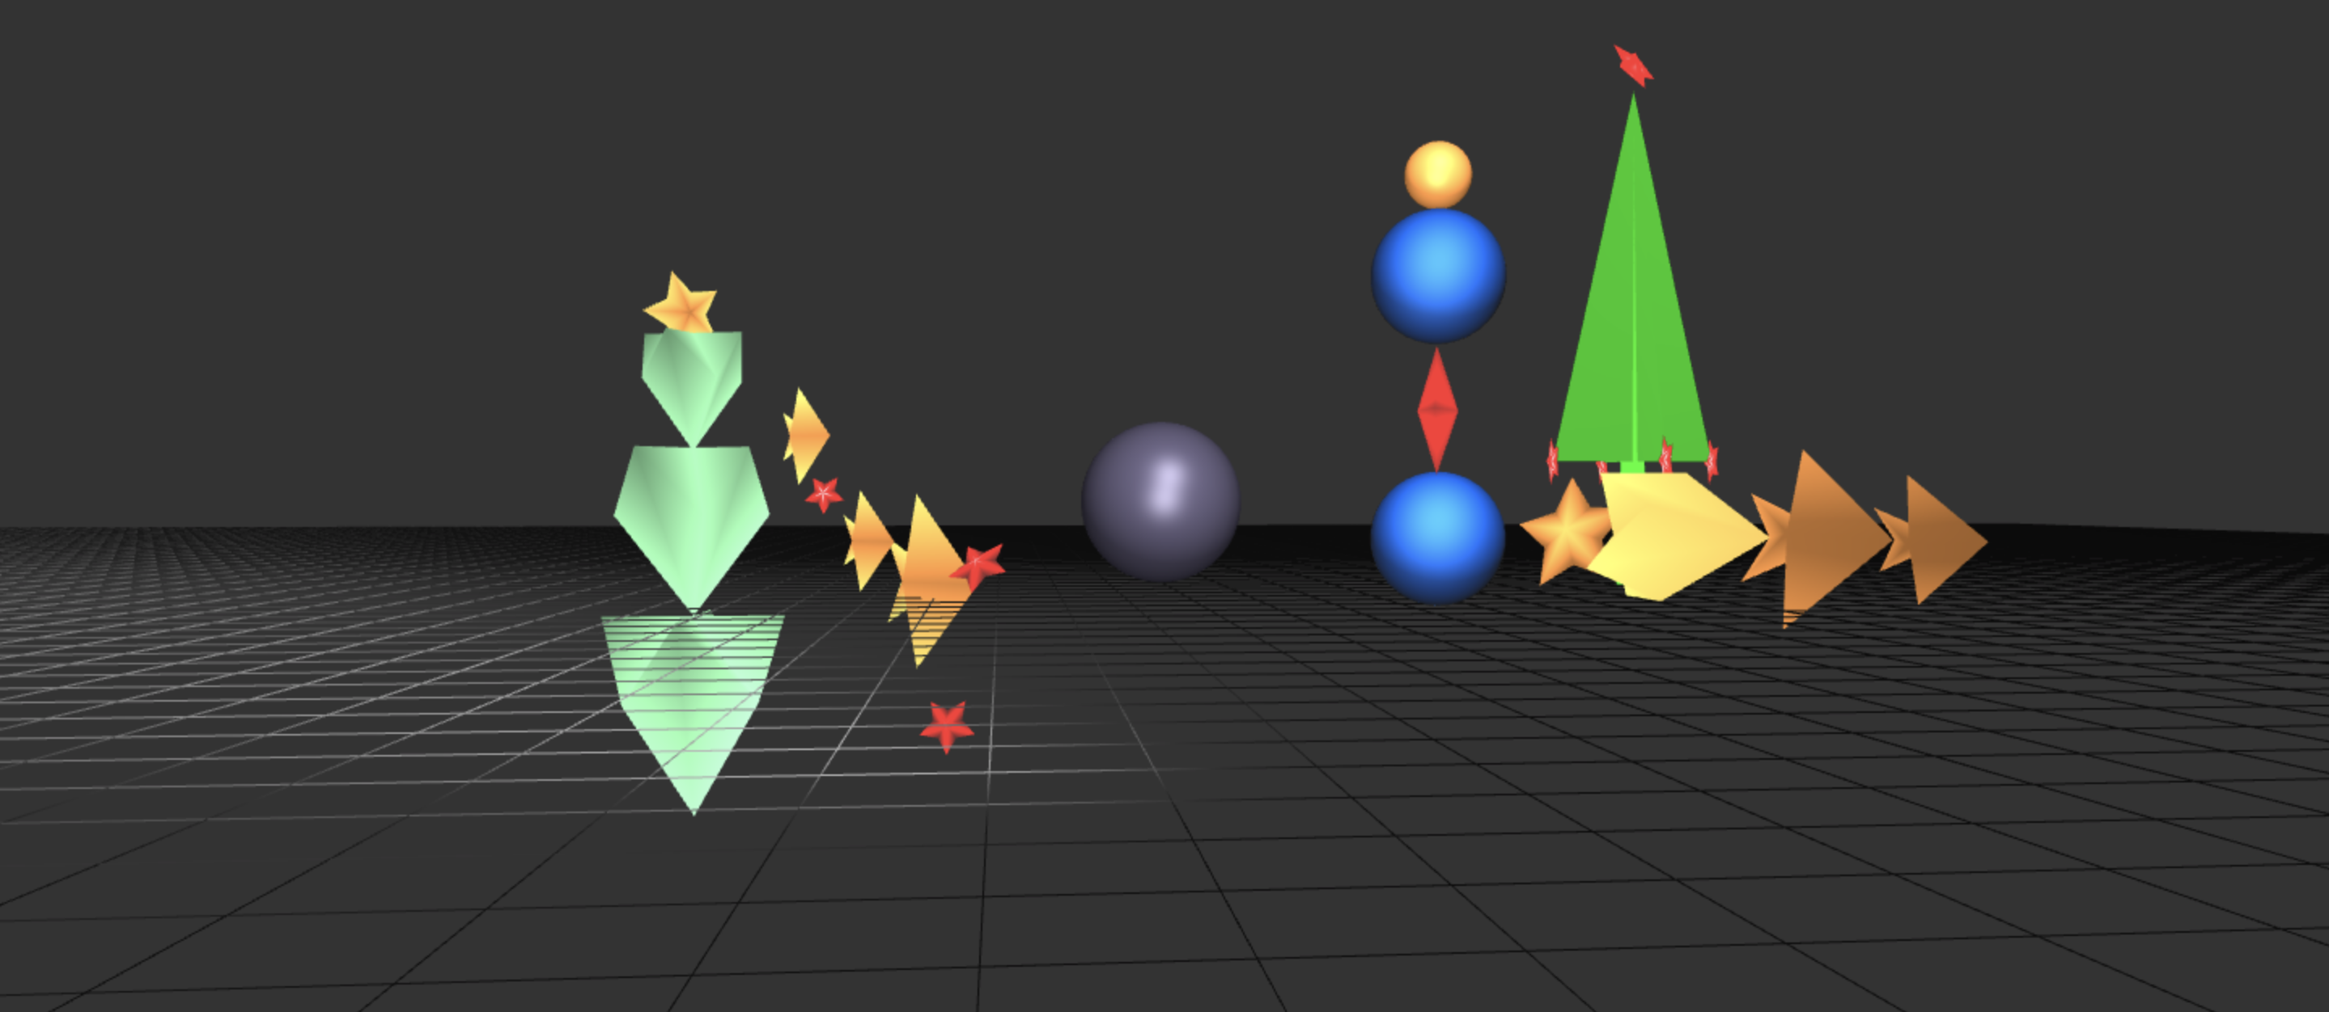

Figure 6 Different Lamp Position

Figure 6 shows a result of a scene of different lamp position.

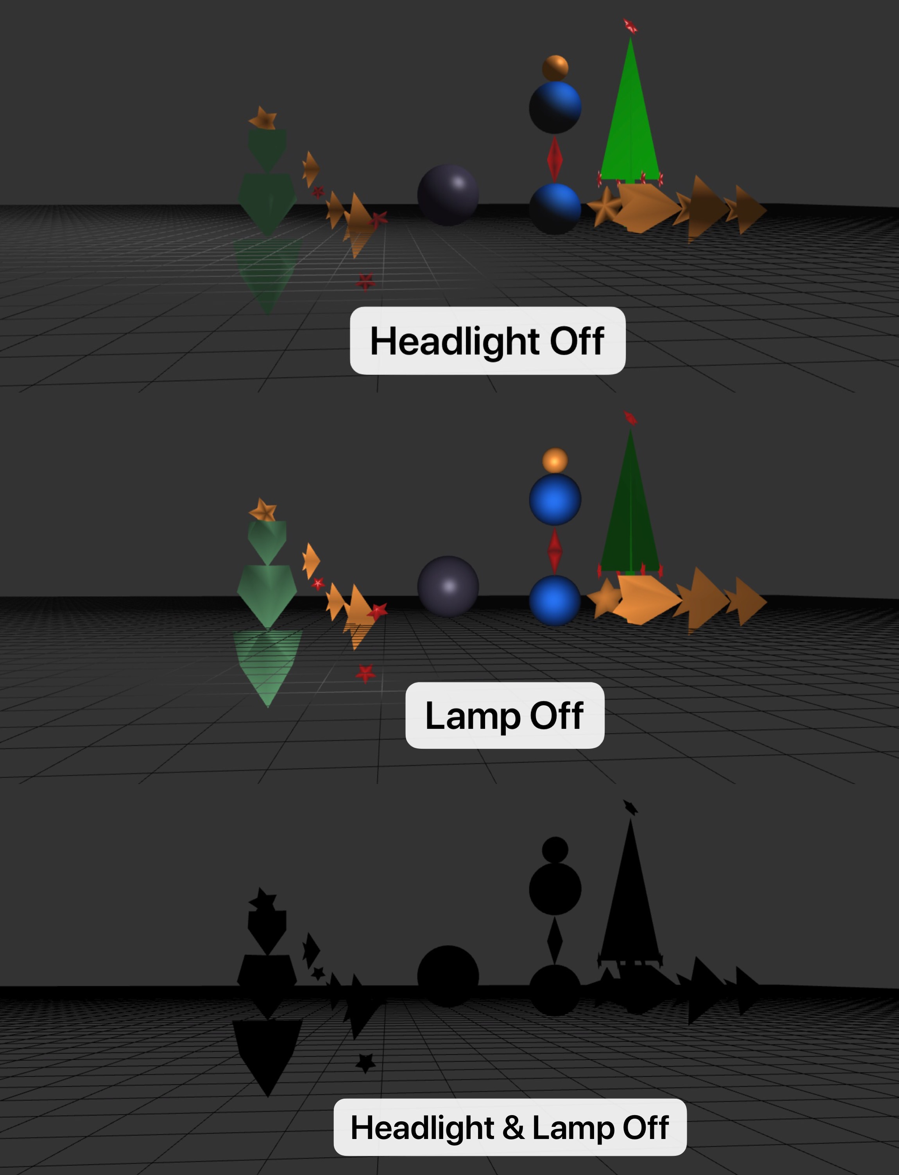

Figure 7 Headlight & Lamp Off

Figure 7 shows results of turning headlight off, turning lamp off and turning headlight & lamp off.

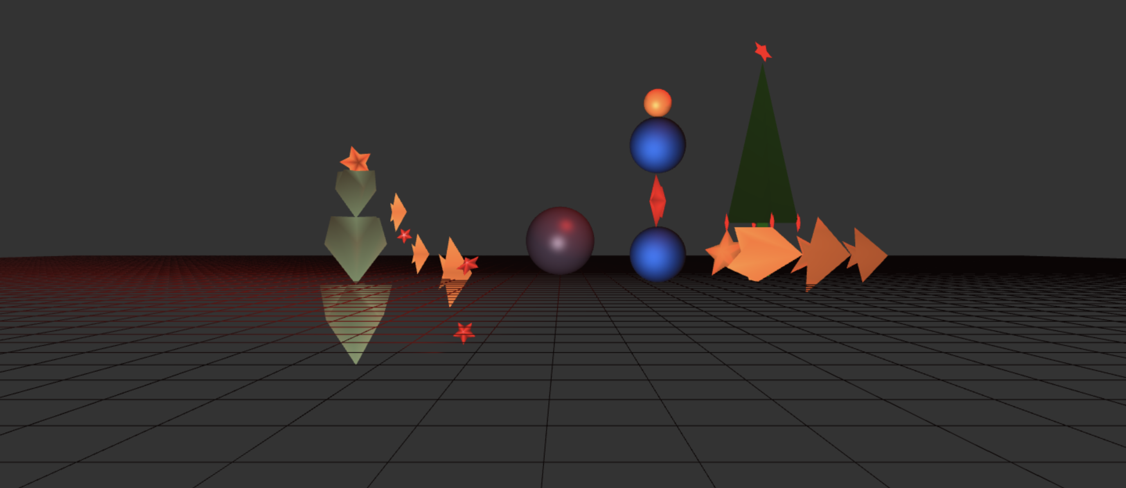

Figure 8

Figure 8 shows result of R, G, B values (from 0 to 1.0) for ambient, diffuse, and specular light, where ambient R = 1, G = 0, B = 0, diffuse R = 1, G = 0, B = 0, specular R = 1, G = 0, B = 0.

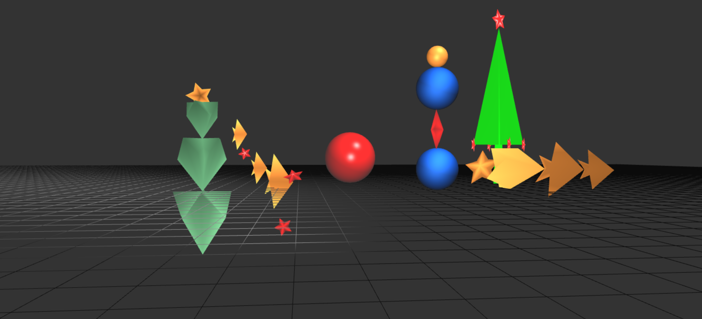

Figure 9 Change Sphere’s material

Figure 9 shows a result of changing the middle sphere’s material.

* **Scene Graph**

Figure 10 shows a scene graph diagram of the project. The nodes labeled with T mean a matrix translation. Those labeled with R mean a matrix rotation. The nodes labeled with s mean a matrix scale.

Figure 10 scene graph